1. **Steps for creating Alarms From the section cloud watch :-**

**a. Go to AWS console page**

**b. Search for CLOUD WATCH interface page at search bar option**

**c. Then select ALARMS from left side of the page**

**d. Select create IN ALARMS like as shown below images**

**e. By adding some credentials at required tabs shown below**

1. **After entering all finally select create tab ..**

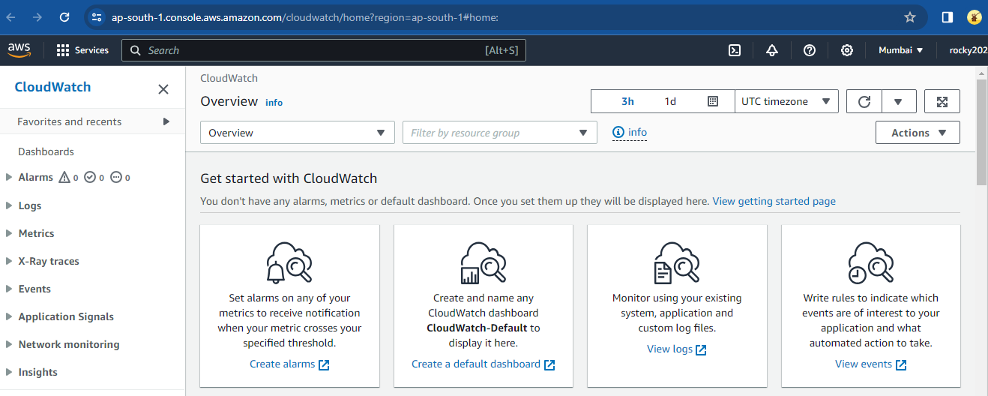

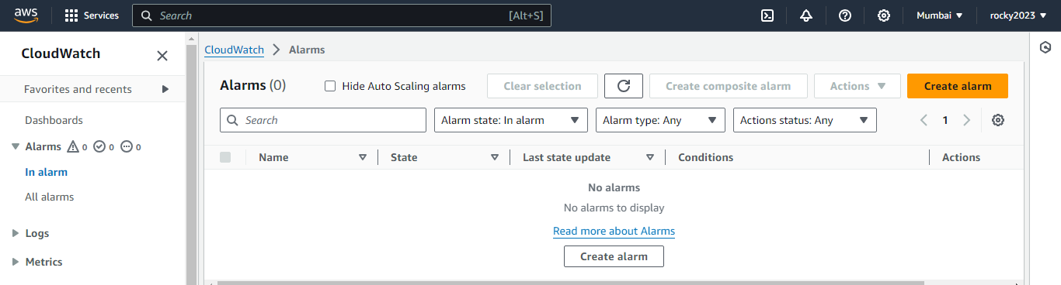

**2)** **Next specify some metric conditions :-**

**a. Select matrix**

**b. Add credentials**

**c. As swohn in below images.**

**D Finally select create matrix**

